- Abstract:

Digital transformation in healthcare increasingly focuses on improving efficiency, automation, and data-driven decision-making. One critical challenge faced by hospitals and clinics is the manual tracking and identification of basic medical supplies, which is slow, prone to error, and difficult to monitor in real time.
This project presents an AI-based prototype for automatic detection of common medical supplies using the Roboflow platform and a YOLOv11 object-detection model. A dataset consisting of 119 images was collected and annotated, containing three object classes: bandage, medicine, and thermometer. The dataset was divided into training (80 images), validation (25 images), and testing (14 images). Preprocessing and augmentation steps were applied to improve generalization across different lighting, orientations, and backgrounds. The trained YOLOv11 model achieved strong performance, with mAP@50 of 97.1%, precision of 99.3%, and recall of 97.0%, demonstrating reliable detection capability.
Experimental testing showed that the model accurately recognized objects in various real-world scenarios, including different packaging styles and placement angles. Although the prototype is limited by dataset size and object variety, the results indicate significant potential for integrating AI-based object detection into healthcare logistics, inventory monitoring, and digital hospital systems. Future work may expand the dataset, include more supply categories, and integrate counting and automated inventory updating to support smarter clinical workflows.

- Problem Statement
Hospitals and clinics rely heavily on the continuous availability of basic medical supplies such as medicines, bandages, and thermometers. However, in many healthcare settings, the identification, counting, and monitoring of these supplies are still done manually. This process depends on staff availability, accuracy, and time — which increases the chances of human error, misplaced items, shortages, or overstocking.
Manual inventory checking also becomes difficult as the number of supplies and storage locations increases. Without real-time visibility, healthcare workers may face delays in finding essential items, which can indirectly affect patient care and workflow efficiency.
Therefore, there is a need for an intelligent, automated system that can recognize and help track medical supplies using computer vision. Such a system could support faster identification, reduce manual workload, and contribute to smarter digital hospital management.
- System Overview:

  - Data Collection and Annotation:
Images of medical supplies, including medicines, bandages, and thermometers were captured from different angles, backgrounds, and lighting conditions. These images were uploaded to Roboflow, where each object was manually annotated using bounding boxes. Annotation ensures that the model learns exactly where and what each object is.

  - Model Training:
The YOLOv11 object-detection architecture was selected due to its balance between accuracy and speed. Using Roboflow Train, the model was trained to detect three object classes: bandage, medicine, and thermometer. During training, the model learned visual features such as shape, color, text, and object boundaries.

  - Mobile App Integration
To make the system portable and easier to use, a simple mobile application named “Roboflow” was created.

When opened, the application displays a button labeled “Start Medical Scanner.”
On tapping the button, the user is redirected to the hosted model web-page, where the detection system can be accessed directly through the phone.

This mobile layer does not train the model, but acts as an interface that:

- allows quick access anywhere
- makes the system easy for non-technical users
- demonstrates practical real-world deployment

This shows how AI tools developed in Roboflow can be integrated into mobile environments to support digital healthcare workflows.

- Dataset Creation:
The foundation of our computer vision project is a custom-curated dataset designed to recognize essential medical inventory. The dataset creation process was managed entirely within Roboflow, a comprehensive platform for computer vision workflows. This stage involved three critical phases: image collection, annotation, and dataset partitioning.

  - Data Collection:
We collected a total of 119 images representing real-world scenarios where medical supplies might be found, such as on tables, held in hand, or in varying lighting conditions. The dataset focuses on three specific classes of medical items essential for basic first aid and home healthcare:
Medicine: This is the most represented class with 67 annotations. It includes various forms of medication packaging, such as bottles and boxes (e.g., Calpol, syrup bottles).
Bandage: There are 52 annotations for this class, identifying boxes of adhesive bandages (e.g., Saniplast)
Thermometer: There are 48 annotations for digital thermometers, often capturing the device in its packaging or being held by a user.
  - Annotation Process:
Each image was manually annotated using bounding boxes. This supervised learning approach involves drawing precise rectangles around the objects of interest and labeling them with their corresponding class (Medicine, Bandage, or Thermometer). The class distribution is relatively balanced, which is crucial for preventing the model from becoming biased toward detecting only the most frequent item.
  - Dataset Split:
To ensure a scientifically rigorous evaluation of our model, the 119 total images were partitioned into three distinct subsets:
Training Set (80 images): This comprises roughly 67% of the data. These images were used by the YOLOv11 algorithm to learn the visual features of the medical supplies, such as text on boxes, shapes of bottles, and color schemes.
Validation Set (25 images): Representing approximately 21% of the data, this set was used during the training process to tune hyperparameters and monitor for overfitting. It acts as a "practice exam" for the model.
Test Set (14 images): The remaining 12% were held back completely until the end of the project. These images were used solely for the final performance metrics calculation, providing an unbiased estimate of how the medical scanner would perform in real-world use cases.
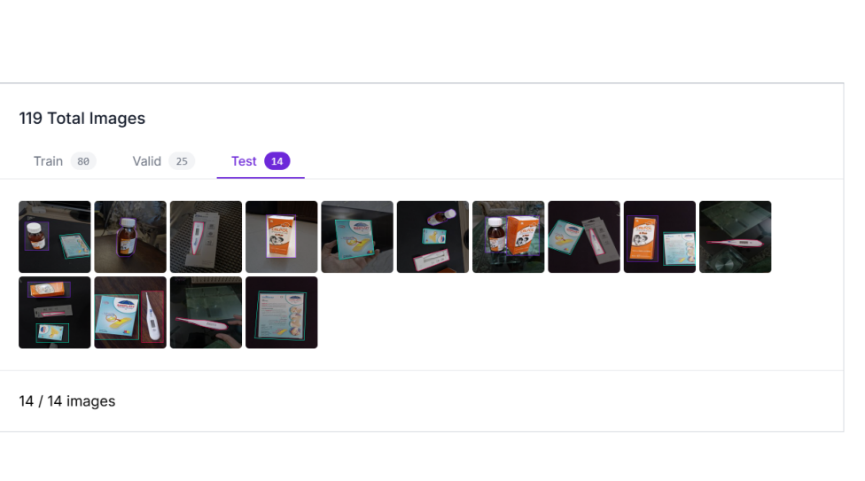
- Model Type and Selection:
5.1 The YOLOv11 Architecture:
YOLO (You Only Look Once) is a single-stage object detection architecture. Unlike older two-stage detectors (like R-CNN) that first propose regions and then classify them, YOLO looks at the entire image at once. It predicts bounding boxes and class probabilities simultaneously in a single forward pass through the neural network. This architectural difference makes it significantly faster and more efficient, which is the primary reason it is the industry standard for real-time applications.

5.2 Selection Rationale:
Real-Time Inference: For a "Medical Scanner" application, the user experience relies on speed. When a user captures an image via our mobile interface, the feedback must be near-instantaneous. YOLOv11 offers the lowest latency, ensuring that the Digital Transformation of the inventory process does not introduce lag that would frustrate hospital staff.
High Accuracy (The "Accurate" Configuration): Medical inventory requires precision; misclassifying a medication could have serious consequences. As shown in our Roboflow dashboard, we selected the "Accurate" model type (likely a larger parameter version like YOLOv11-Large or Extra Large). This choice prioritizes high detection confidence over raw speed, which is appropriate for a medical context where correctness is paramount.
Transfer Learning (COCO Checkpoint): We utilized Transfer Learning by starting with the "COCOs" checkpoint. Instead of training the model from scratch (which requires massive datasets), we used a model pre-trained on the Common Objects in Context (COCO) dataset. This allowed the model to already understand basic edges, shapes, and textures, enabling it to learn our specific medical classes (Medicine, Bandage, Thermometer) rapidly and with high accuracy (97.1% mAP) despite our smaller dataset size.
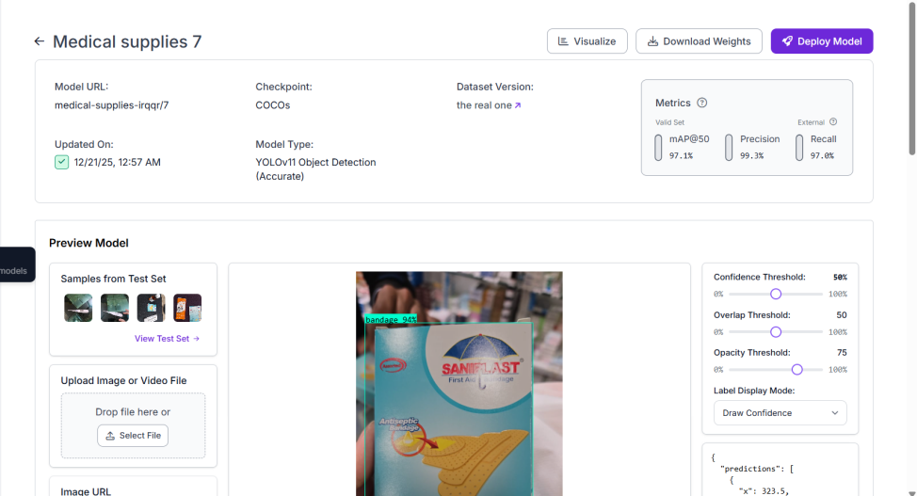

5.3 Training Configuration:
The model was trained with the following parameters observed from our training metrics:
Epochs: The model was trained for approximately 300 epochs.
Convergence: The loss graphs (Box Loss and Object Loss) show that the model learned the majority of features within the first 50 epochs, achieving stability quickly. This indicates that the YOLOv11 architecture was well-suited to the complexity of our dataset.

Input Resolution: By using Roboflow's preprocessing, images were resized to a standard input resolution compatible with the YOLO architecture, ensuring consistent detection regardless of the camera used to take the picture.
- Mobile App Integration:

  - Application Overview:
The practical implementation of our Digital Transformation project culminates in a mobile application, enabling the object detection model to be used portably in real-world scenarios. We developed a mobile application wrapper named "Roboflow" to serve as the user interface for our medical supply scanner. The primary objective of this integration was to decouple the model from a desktop environment, making the technology accessible to users in dynamic environments such as hospital wards or storage facilities.

  - User Interface:
The application is designed with a focus on simplicity and ease of access for medical personnel. Upon launching the app, the user is presented with a clean, minimal interface containing a primary call-to-action button labeled "Start Medical Scanner". Tapping this button triggers a web-view redirection, seamlessly transitioning the user from the local application environment to the hosted web interface where the YOLOv11 model is deployed. This workflow minimizes the training required for staff, as the interaction is intuitive and requires a single tap to initiate.

This mobile integration represents the core value of our DTI course project: portability. By moving the model from a desktop development environment to a mobile app, we have transformed a static computer vision experiment into a deployable tool. This allows for potential use cases such as checking inventory in hospital storage rooms, remote clinics, or emergency response vehicles, effectively digitizing the inventory management process at the point of care.

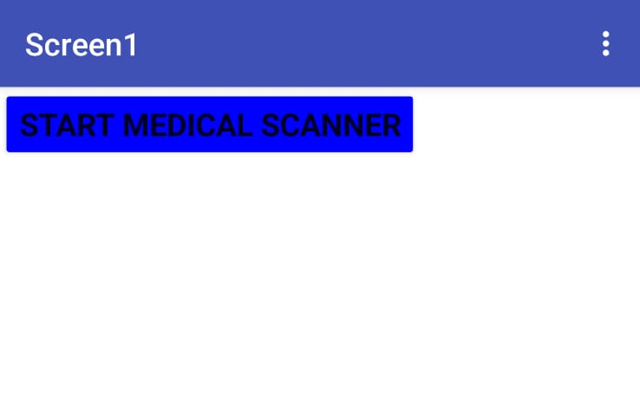

- Evaluation and Results:

The performance of the YOLOv11 model was rigorously evaluated using standard computer vision metrics on our held-out test set. The results demonstrate exceptional accuracy for a prototype system, validating the effectiveness of our dataset and training methodology.

Mean Average Precision (mAP): The model achieved a mAP@50 of 97.1%. This metric indicates that in 97.1% of cases, the model correctly identified and localized the medical supplies with an Intersection over Union (IoU) of at least 0.5. This high score suggests the model is highly reliable for inventory counting tasks.

Precision: The precision score was 99.3%. This implies a very low false-positive rate; when the scanner claims to see a "Thermometer" or "Bandage," it is almost certainly correct.

Recall: The recall score was 97.0%. This indicates that the model successfully detected 97% of all actual medical items present in the images, missing only a negligible fraction of the inventory.

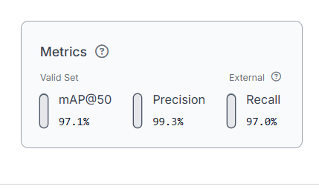

5.1 Training Stability and Convergence:
An analysis of the training graphs reveals a stable learning process. The Box Loss (error in locating the object) and Class Loss (error in identifying the object type) both showed a sharp decline within the first 50 epochs, indicating rapid learning. The metrics plateaued and stabilized around epoch 100, maintaining high performance through to epoch 300 without significant signs of overfitting. This stability confirms that the model generalizes well to new images rather than just memorizing the training data.

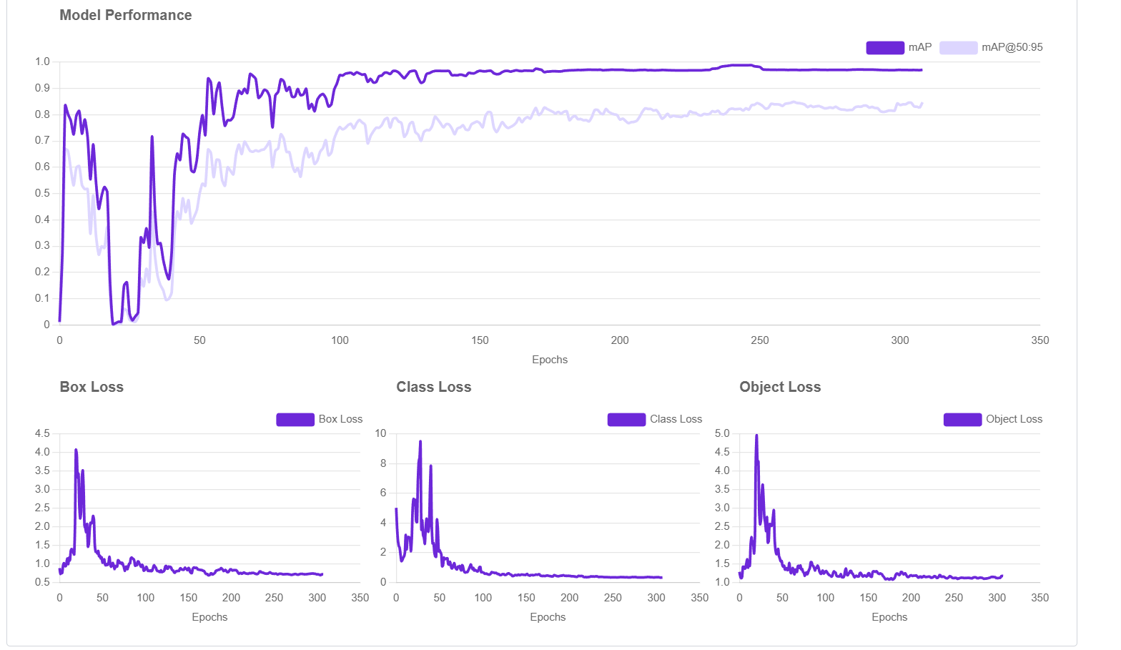

- Conclusion:
This project successfully applied the principles of Digital Transformation to the field of biomedical engineering by digitizing the manual process of medical inventory management. By leveraging the Roboflow platform for dataset curation and the state-of-the-art YOLOv11 architecture for object detection, we developed a highly accurate prototype capable of identifying medicines, bandages, and thermometers with 97.1% accuracy.

The integration of this model into a mobile application wrapper marked a significant step forward, moving the technology from a theoretical experiment to a portable, deployable tool. This "Cloud-Edge" synergy allows for flexible usage in diverse hospital settings, reducing the administrative burden on healthcare staff and minimizing human error in stock checks.

While current limitations regarding dataset size and internet dependency exist, the project lays a solid foundation for a comprehensive, automated inventory system. Future iterations could expand the class library and implement offline inference, further solidifying the role of computer vision in modern healthcare logistics. Ultimately, this course project demonstrates how Industry 4.0 technologies can be practically implemented to solve real-world biomedical challenges.

